# Section 1.1: Review of Functions

In this section, we provide a formal definition of a function and examine several ways in which functions are represented – through tables, formulas, and graphs.

## Functions

Given two sets $A$ and $B$, a set with elements that are ordered pairs $(x,y)$, where $x$ is an element of $A$ and $y$ is an element of $B$, is a relation from $A$ to $B$. A relation from $A$ to $B$ defines a relationship between those two sets. A function is a special type of relation.

A **function $f$** consists of a set of inputs, a set of outputs, and a rule for assigning each input to exactly one output. The set of inputs is called the **domain** of the function. The set of outputs is called the **range** of the function.

A function maps every element in the domain to exactly one element in the range. Although each input can be sent to only one output, two different inputs can be sent to the same output.

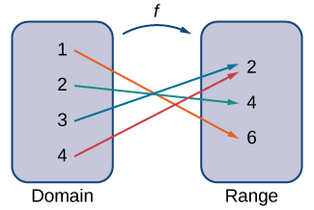

For a general function $f$ with domain $D$, we often use $x$ to denote the input and $y$ to denote the output associated with $x$. When doing so, we refer to $x$ as the **independent variable** and $y$ as the **dependent variable**, because it depends on $x$. Using function notation, we write $y=f(x)$, and we read this equation as “ $y$ equals $f$ of $x$.”

Every function has a domain. However, sometimes a function is described by an equation, with no specific domain given. In addition, sometimes domains are sets with an infinite number of elements. We cannot list all these elements but can describe domain by using interval notation.

Examples

1. For each of the relations below, determine the domain and range and then state whether the relation is a function.

|  |  |
| --- | --- |
| -3 | 9 |
| -2 | 4 |
| 1 | 1 |
| 2 | 4 |
| 3 | 9 |



$\left\{\left(1, -3\right), \left(2,-2\right), \left(3,-1\right), \left(0,0\right), \left(1,1\right), \left(2,2\right), (3,3)\right\}$

1. For the function $f\left(x\right)=3x^{2}+2x-1$, evaluate
$f\left(-2\right)$

$f\left(\sqrt{2}\right)$

$f(a+h)$

2. For each of the following functions, determine the domain and range.

$f\left(x\right)={\left(x-4\right)}^{2}+5$

$f\left(x\right)=\sqrt{3x+2}-1$

$f\left(x\right)=\frac{3}{x-2}$

## Representing Functions

Typically, a function is represented using one or more of the following tools;

* A table
* A graph
* A formula

To determine if a relation is a function from a graph, we use the vertical line test.

**Vertical Line Test**

Given a function $f$, every vertical line that may be drawn intersects the graph of $f$ no more than once. If any vertical line intersects a set of points more than once, the set of points does not represent a function.

Each of these representations can give us an idea of how the function is behaving. When analyzing functions, we typically look for key characteristics, such as the zeros of a function, the $y$-intercept, where the function is increasing/decreasing/constant, etc.

Examples

1. Consider the function $f\left(x\right)=-4x+2$.
   1. Find all zeros of $f$.
   2. Find the $y$-intercept (if any).
   3. Sketch a graph of $f$.
2. If a ball is dropped from a height of 100 ft, its height $s$ at time $t$ is given by the function $s\left(t\right)=-16t^{2}+100$, where $s$ is measured in feet and $t$ is measured in seconds. The domain is restricted to the interval $[0,c]$, where $t=0$ is the time when the ball is dropped and $t=c$ is the time when the ball hits the ground.
   1. Create a table showing the height $s(t)$ when $t=0, 0.5, 1, 1.5, 2$, and $2.5$. Using the data from the table, determine the domain for this function. That is, find the time $c$ when the ball hits the ground.
   2. Sketch a graph of $s$.

## Combining Functions

Now that we have reviewed the basic characteristics of functions, we can see what happens to these properties when we combine functions in different ways, using basic mathematical operations to create new functions.

### Combining Functions with Mathematical Operators

To combine functions using mathematical operators, we simply write the functions with the operator and simplify.

Given two functions $f$ and $g$, we can define four new functions:

Sum: $\left(f+g\right)\left(x\right)=f\left(x\right)+g(x)$

Difference: $\left(f-g\right)\left(x\right)=f\left(x\right)-g(x)$

Product: $\left(f∙g\right)\left(x\right)=f\left(x\right)g(x)$

Quotient: $\left(\frac{f}{g}\right)\left(x\right)=\frac{f\left(x\right)}{g(x)}$ for $g\left(x\right)≠0$

Examples: Given the functions $f\left(x\right)=2x-3$ and $g\left(x\right)=x^{2}-1$, find each of the following functions and state its domain.

$(f+g)(x)$

$(f-g)(x)$

$(fg)(x)$

$\left(\frac{f}{g}\right)(x)$

### Function Composition

When we compose functions, we take a function of a function.

Consider the function $f$ with domain $A$ and range $B$, and the function $g$ with domain $D$ and range $E$. If $B$ is a subset of $D$, then the **composite function $\left(g o f\right)(x)$** is the function with domain $A$ such that

$\left(g o f\right)\left(x\right)=g\left(f\left(x\right)\right)$.

A composite function $g o f$ can be viewed in two steps. First the function $f$ maps each input $x$ in the domain of $f$ to its output $f(x)$ in the range of $f$. Second, since the range of $f$ is a subset of the domain of $g$, the output $f(x)$ is an element in the domain of $g$, and therefore it is mapped to an output $g\left(f(x)\right)$ in the range of $g$.

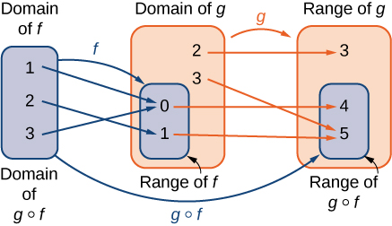

Examples

1. Consider the functions $f\left(x\right)=x^{2}+1$ and $g\left(x\right)=\frac{1}{x}$.
   1. Find $\left(g o f\right)(x)$ and state its domain and range.
   2. Evaluate $\left(g o f\right)(4)$ and $\left(g o f\right)\left(-\frac{1}{2}\right)$.
   3. Find $\left(f o g\right)(x)$ and state its domain and range.
   4. Evaluate $\left(f o g\right)(4)$ and $\left(f o g\right)\left(-\frac{1}{2}\right)$.
2. Consider the functions $f$ and $g$ described in the tables below.

|  |  |
| --- | --- |
| -3 | 0 |
| -2 | 4 |
| -1 | 2 |
| 0 | 4 |
| 1 | -2 |
| 2 | 0 |
| 3 | -2 |
| 4 | 4 |

|  |  |
| --- | --- |
| -4 | 1 |
| -2 | 0 |
| 0 | 3 |
| 2 | 0 |
| 4 | 5 |

* 1. Evaluate $\left(g o f\right)(3)$ and $\left(g o f\right)(0)$.
  2. State the domain and range of $\left(g o f\right)(x)$.
  3. Evaluate $\left(f o f\right)(3)$ and $\left(f o f\right)(0)$.
  4. State the domain and range of $\left(f o f\right)(x)$.

1. A store is advertising a sale of 20% off all merchandise. Caroline has a coupon that entitles her to an additional 15% off any item, including sale merchandise. If Caroline decides to purchase an item with an original piece of $x$ dollars, how much will she end up paying if she applies her coupon to the sale price? Solve this problem by using a composite function.

## Symmetry of Functions

The graphs of certain functions have symmetry properties that help us understand the function and the shape of its graph. Below are two different ways in which we can look at symmetry:

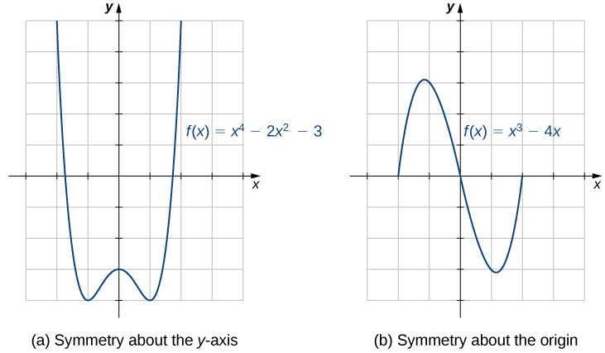

If we are given a graph of a function, it is easy to see whether the graph has one of these symmetry properties. But without a graph, how can we determine algebraically whether a function $f$ has symmetry?

If $f\left(x\right)=f(-x)$ for all $x$ in the domain of $f$, then $f$ is an **even function**. An even function is symmetric about the $y$-axis.

If $f\left(-x\right)=-f(x)$ for all $x$ in the domain of $f$, then $f$ is an **odd function**. An odd function is symmetric about the origin.

Examples

1. Determine whether each of the following functions is even, odd, or neither.

$f\left(x\right)=-5x^{4}+7x^{2}-2$

$f\left(x\right)=2x^{5}-4x+5$

$f\left(x\right)=\frac{3x}{x^{2}+1}$

For each of the graphs below, use the vertical line test to determine whether each of the given graphs represents a function. If the graph represents a function, then determine the following for the graph:

1. Domain and range
2. $x$-intercept, if any (estimate if necessary)
3. $y$-intercept, if any (estimate if necessary)
4. The intervals for which the function is increasing
5. The intervals for which the function is decreasing
6. The intervals for which the function is constant
7. Symmetry about any axis and/or origin
8. Whether the function is even, odd, or neither
9. 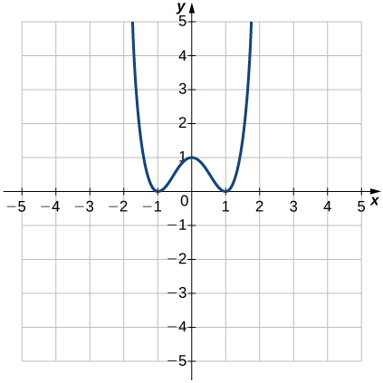
10. 